Name: Aditi Asane
PRN: 2125UDSF1096

DevOps & Cloud MiniProject-03
Students Library Management Platform

URL: http://54.159.126.82:5000/
Git Hub repository link: https://github.com/AditiAsane/smart-library-management-system.git

STEP-1: Create an EC2 instance in the AWS console.
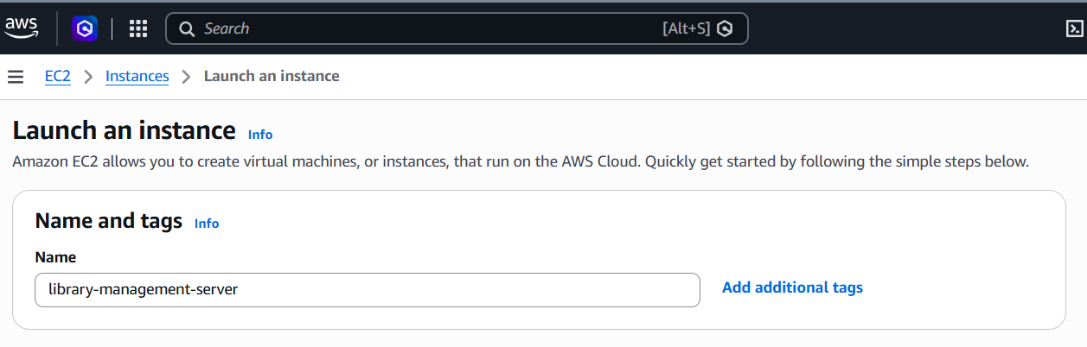
---------------------------------------------------------------------------------------
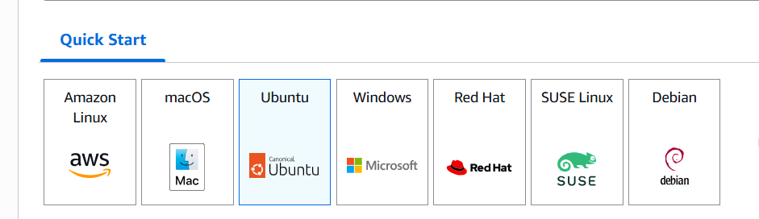
---------------------------------------------------------------------------------------
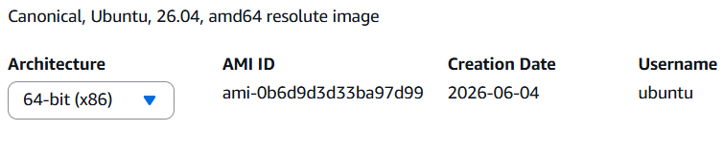
---------------------------------------------------------------------------------------
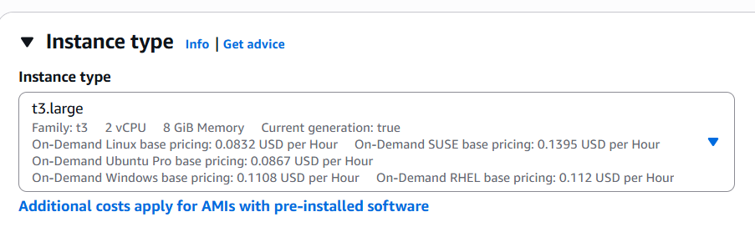
---------------------------------------------------------------------------------------
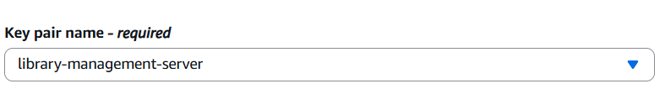
---------------------------------------------------------------------------------------
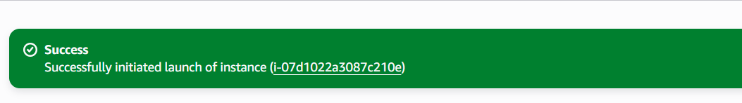

Port range
1: 8080-Jenkins
2: 5000- direct application testing
3. 30080-Kubernetes

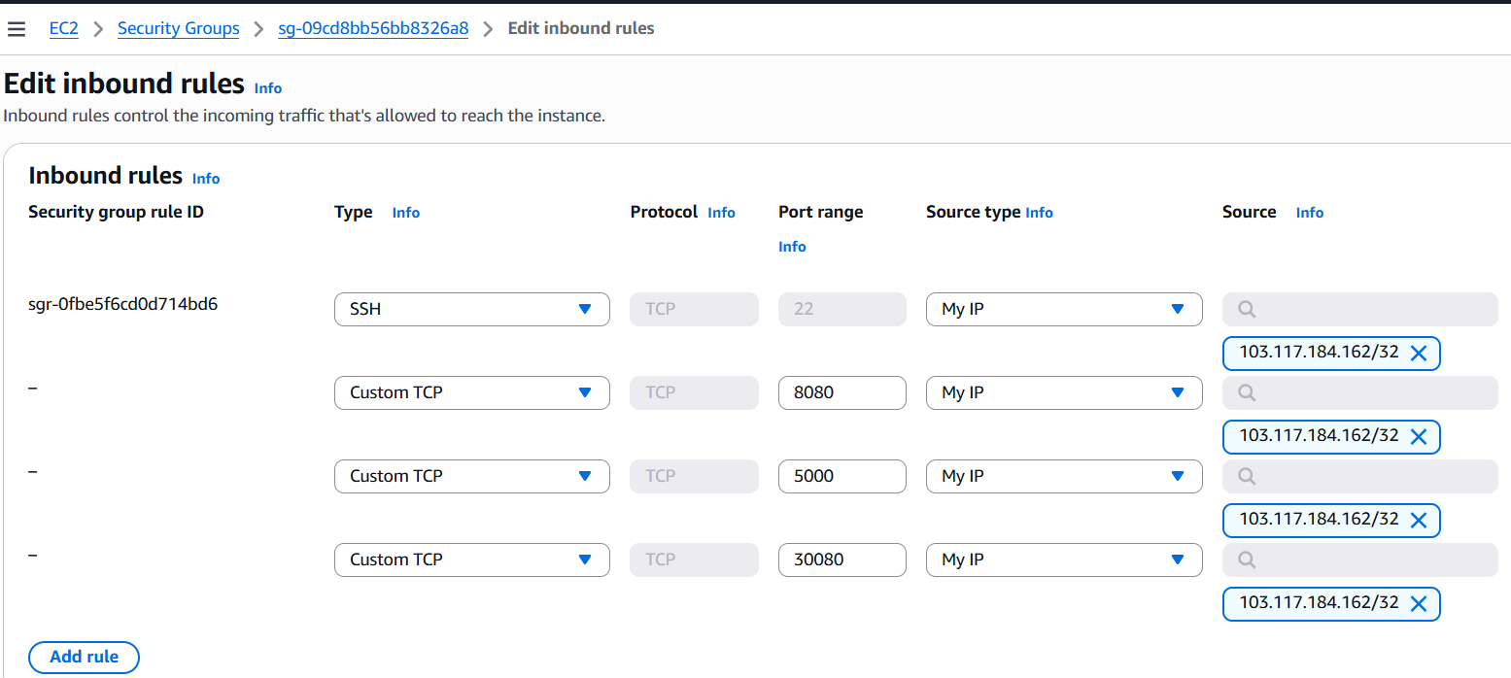
---------------------------------------------------------------------------------------

Step 2: Connecting to MobaXterm through SSH
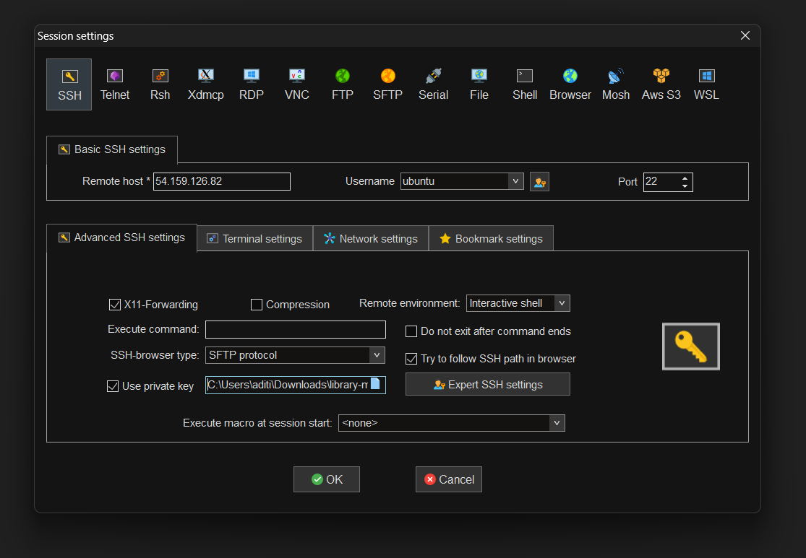

Connected to MobaXterm
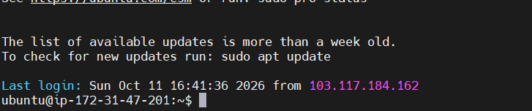

Create the application

Step 1 — Verify your Ubuntu server
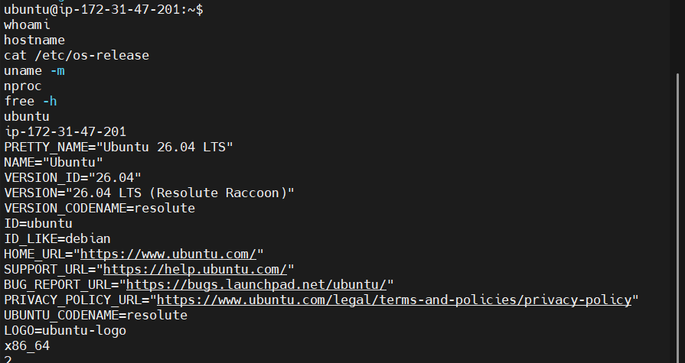

Step 2 — Update Ubuntu and install the required tools
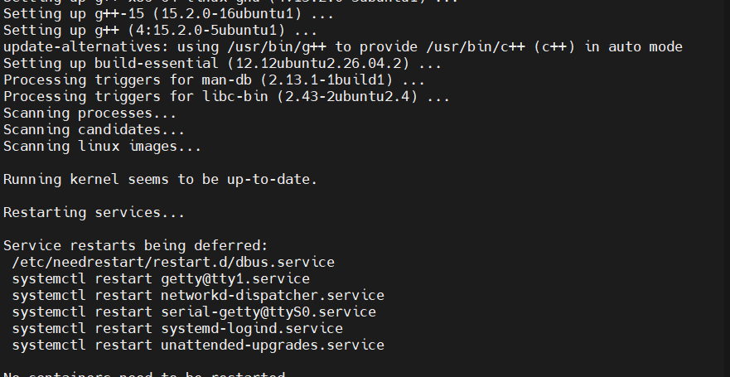

Step 3 — Verify installed versions
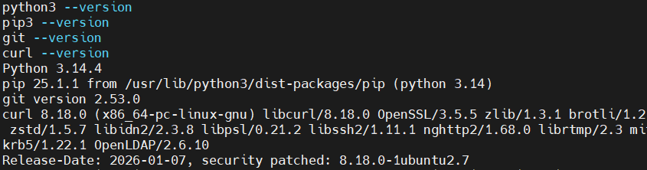

Step 4 — Create requirements.txt
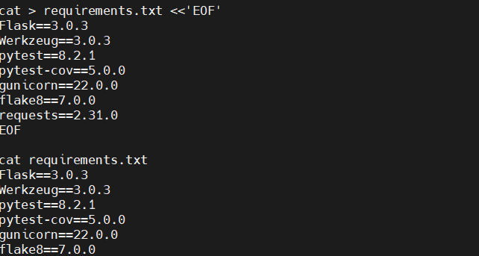
Step 6 — Install the dependencies
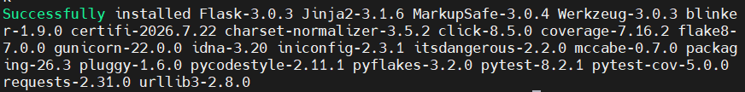
Step 7 — Verify everything
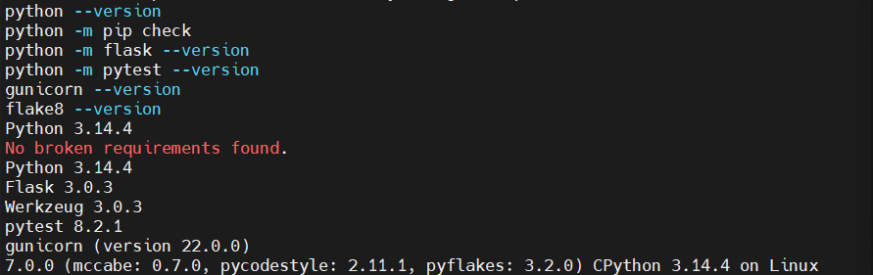

Step 8 — Create the project structure
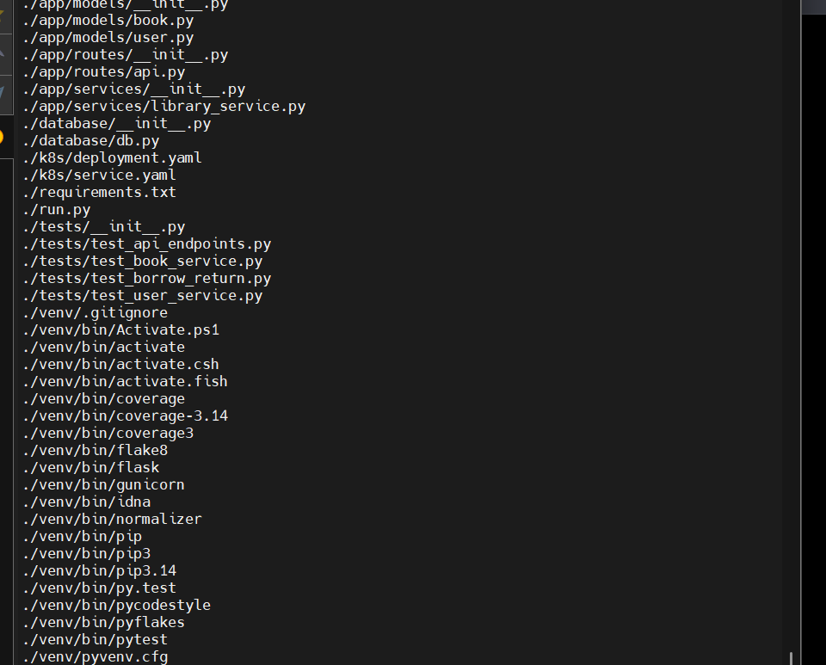

Step 9 — Add the database models

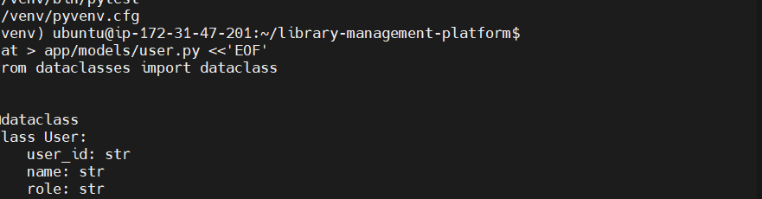

Step 10 — Verify the files
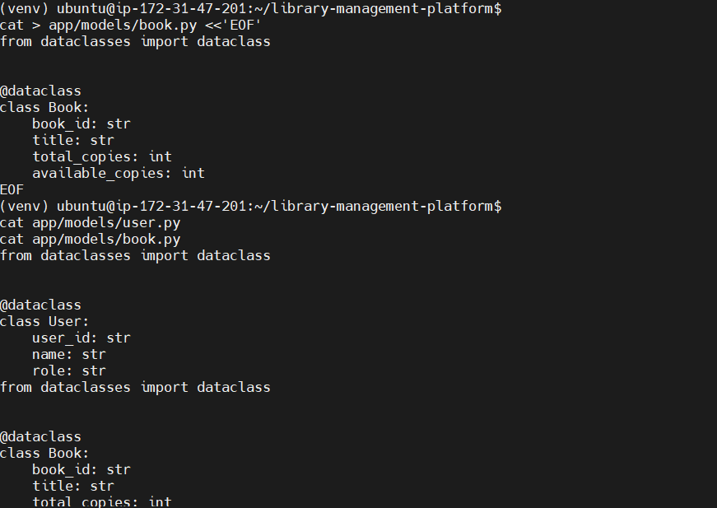

Step 11 — Create the database
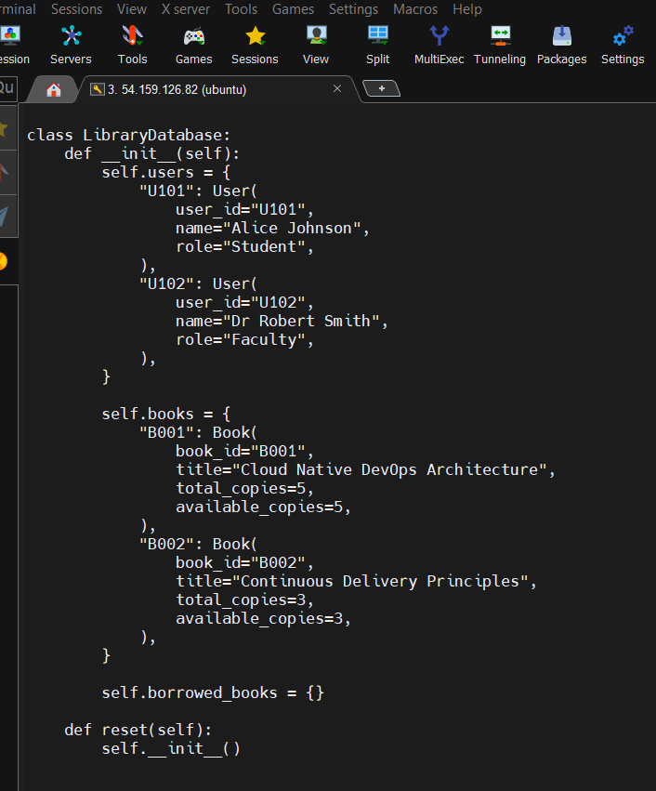

Step 12 — Verify the database
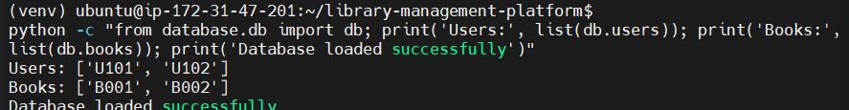
Step 13 — Implement the library service
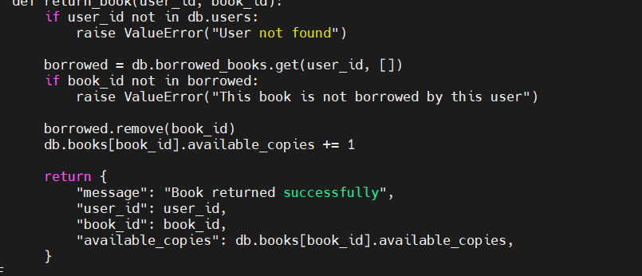
Step 14 — Verify the service
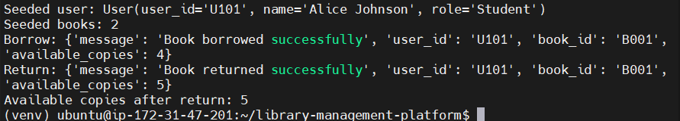

Step 15 — Create the API routes
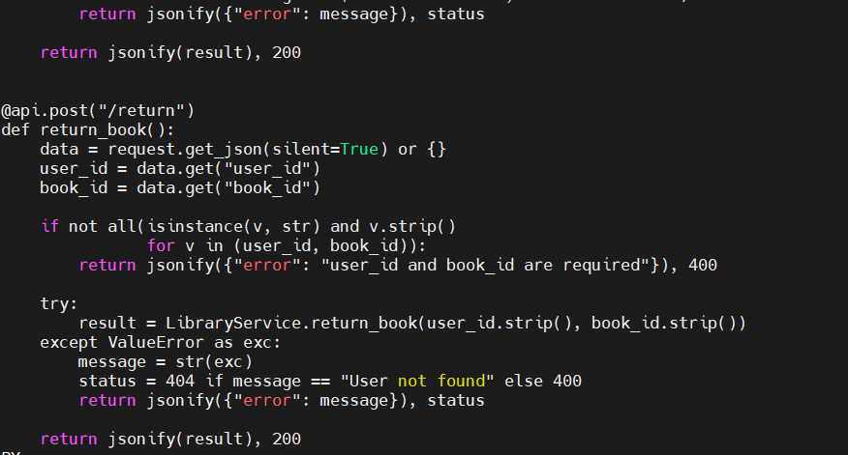
Step 15A — Check the API file

Step 16 — Create the Flask application
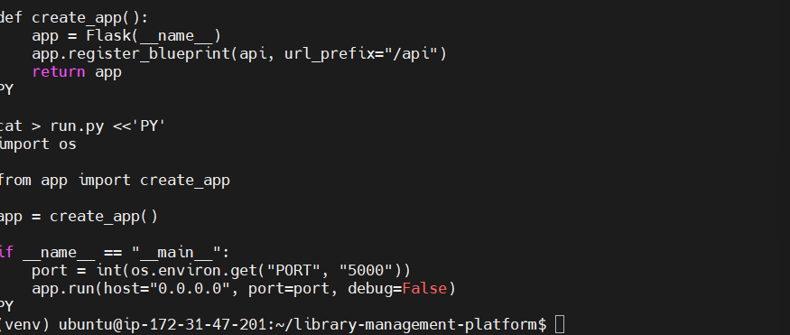
Step 17 — Test the API
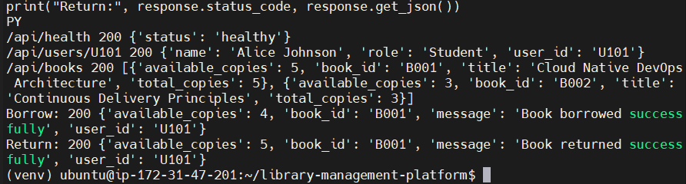
Step 18 — Create the automated tests
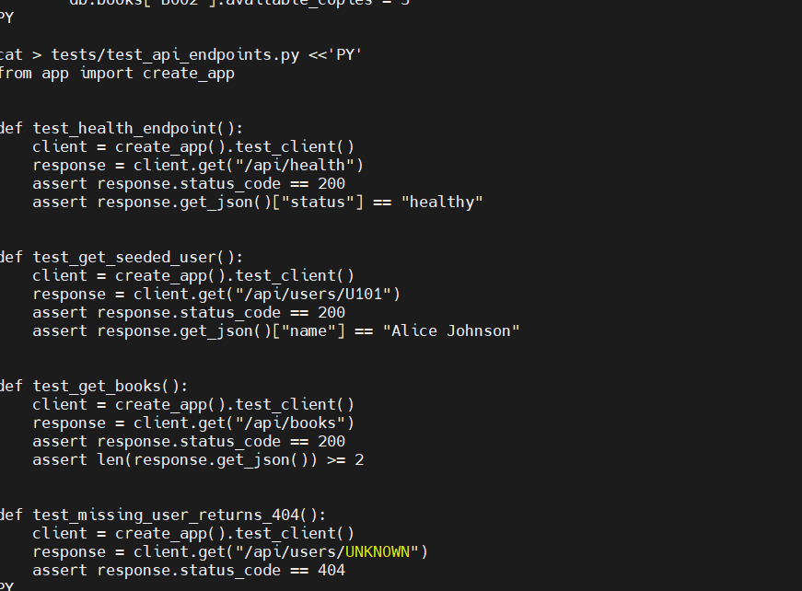
Step 19 — Run the test suite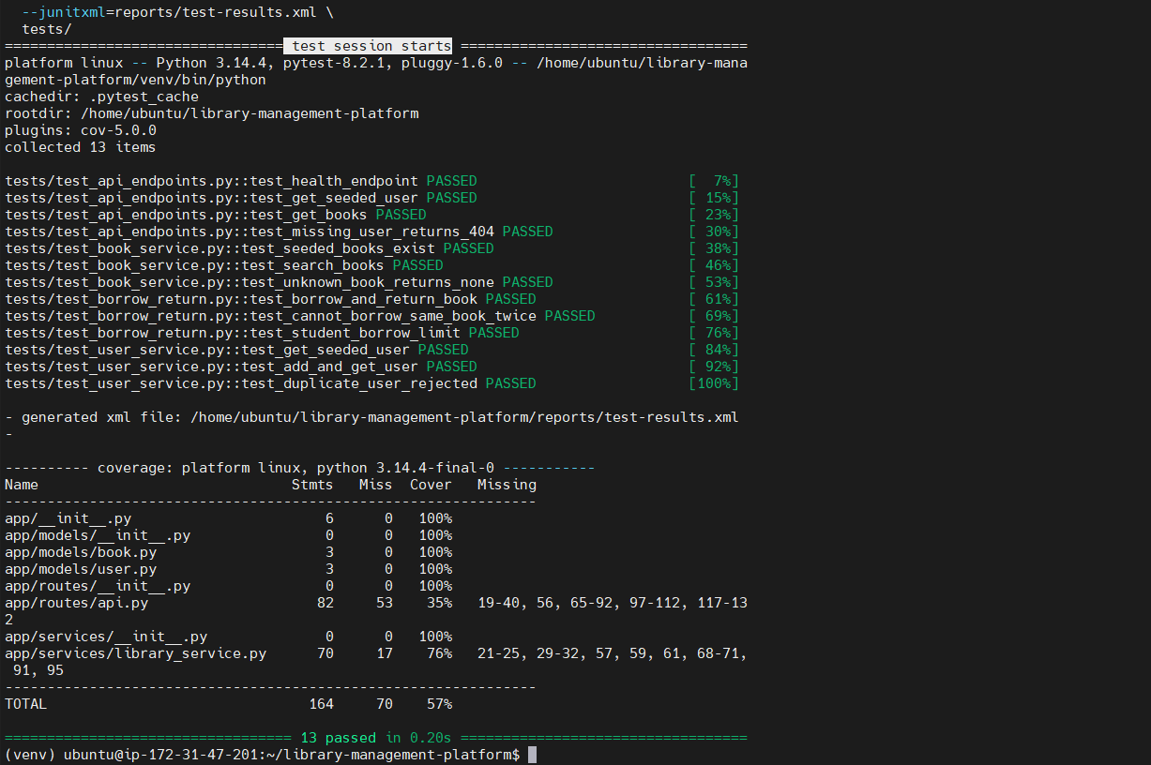

Confirm that Flake8 is clean.

Build the Docker image
Step 22 — Create the Dockerfile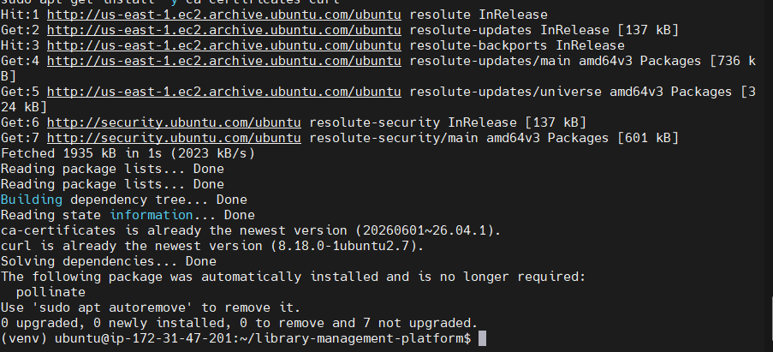
Start Docker automatically
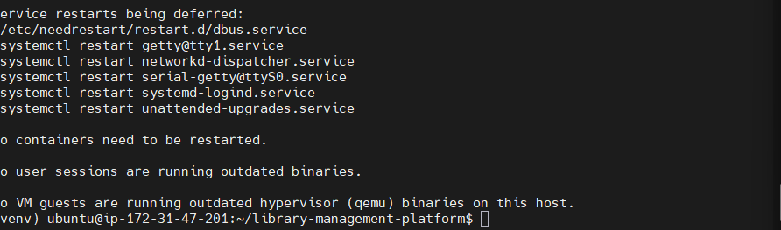
Verify Docker
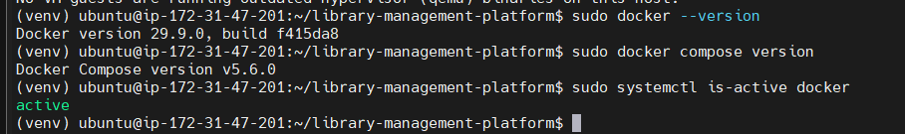

Test that Docker can run a container
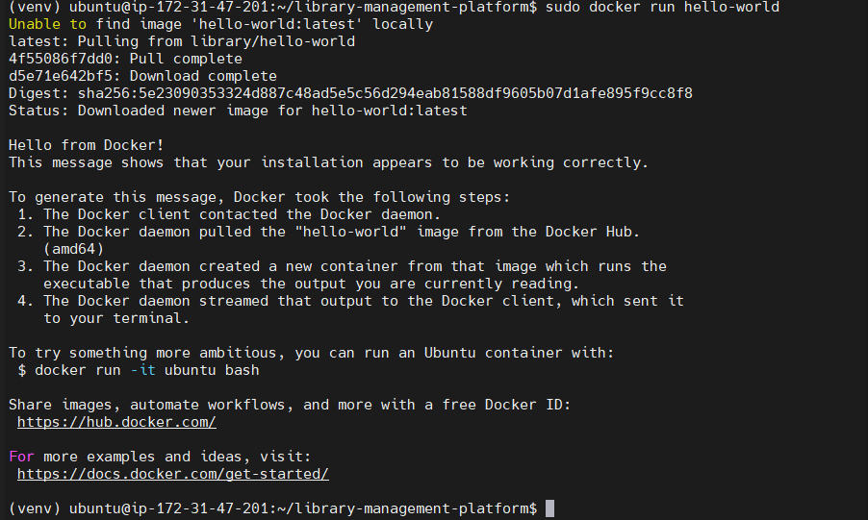
Step 23 — Check your project files
- PWD

ls -la
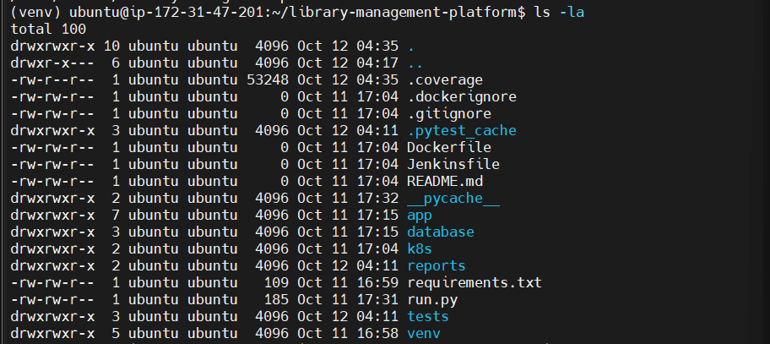

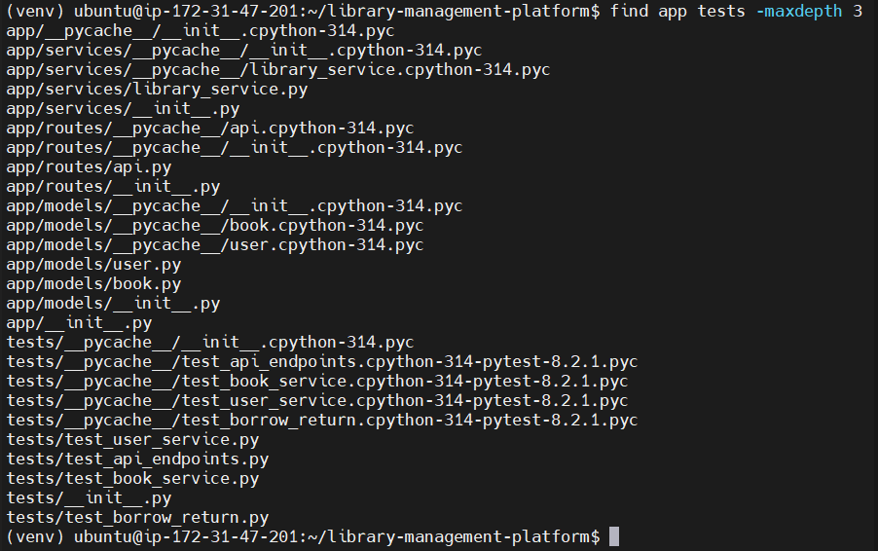

Step 2 — Create the Dockerfile
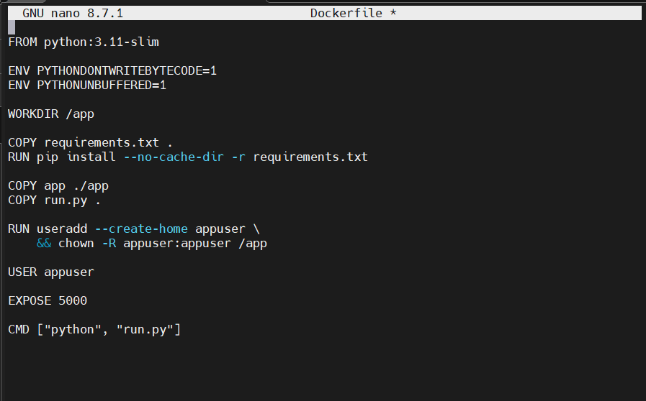

Step 3 — Build the Docker image
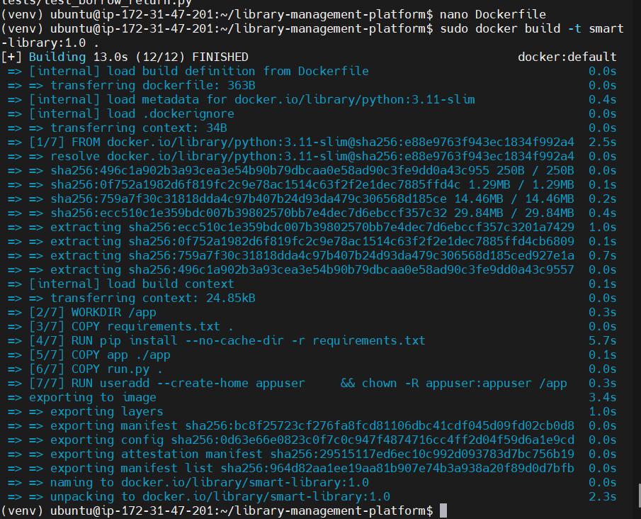

Create the application

Step 1 — Start the container
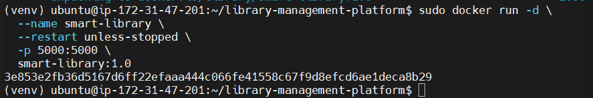

Step 2 — Test the health endpoint
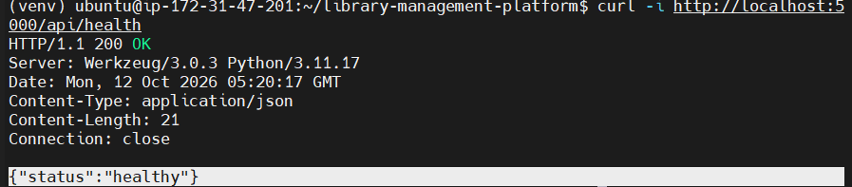
Step 3 — Test the books endpoint
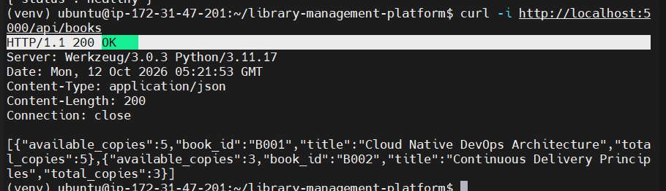
Step 3 — Check the container logs
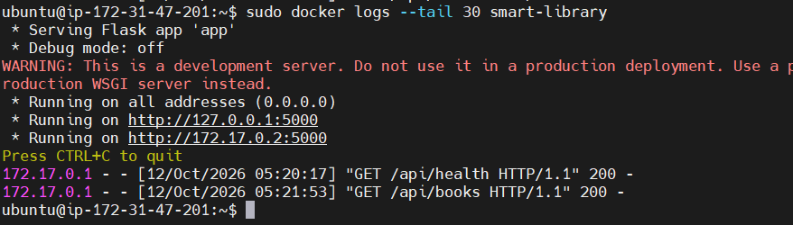Confirm the API response
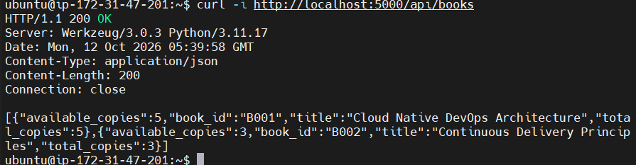
Step 3 — Allow public access on port 5000
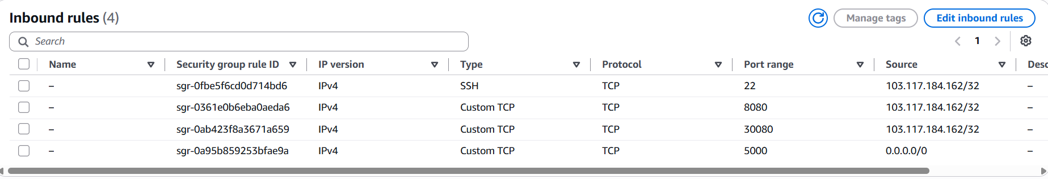

Step 4 — Test from your browser
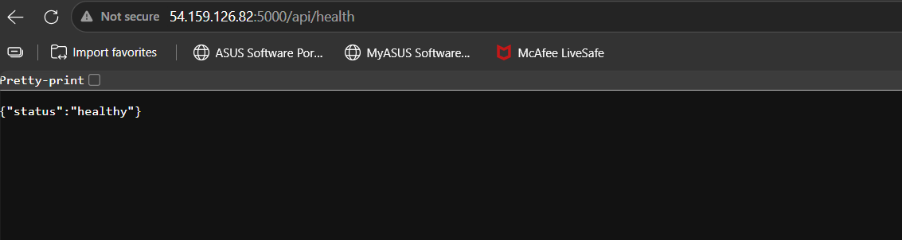
Step 1 — Test the books endpoint
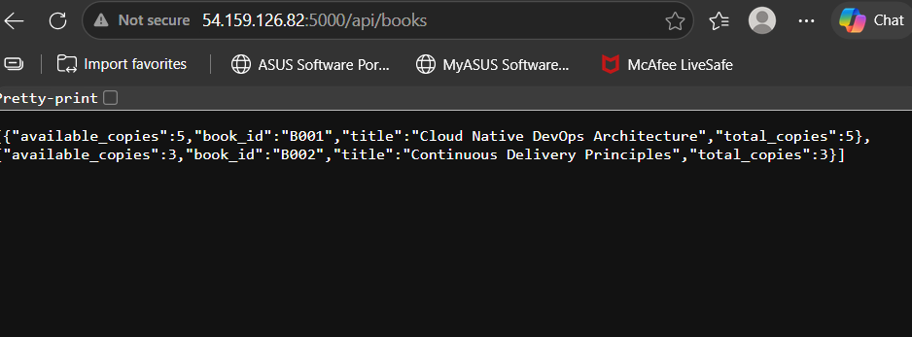

Step 2 — Check the main page
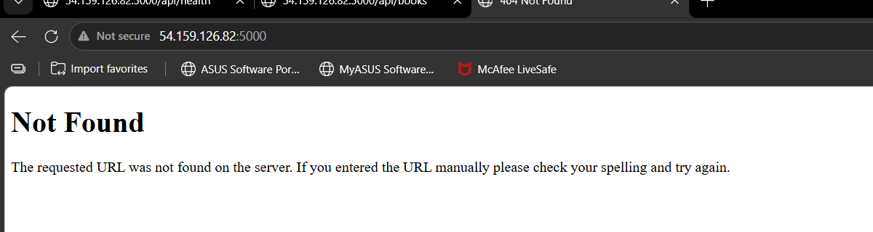
Step 1 — Create the homepage template
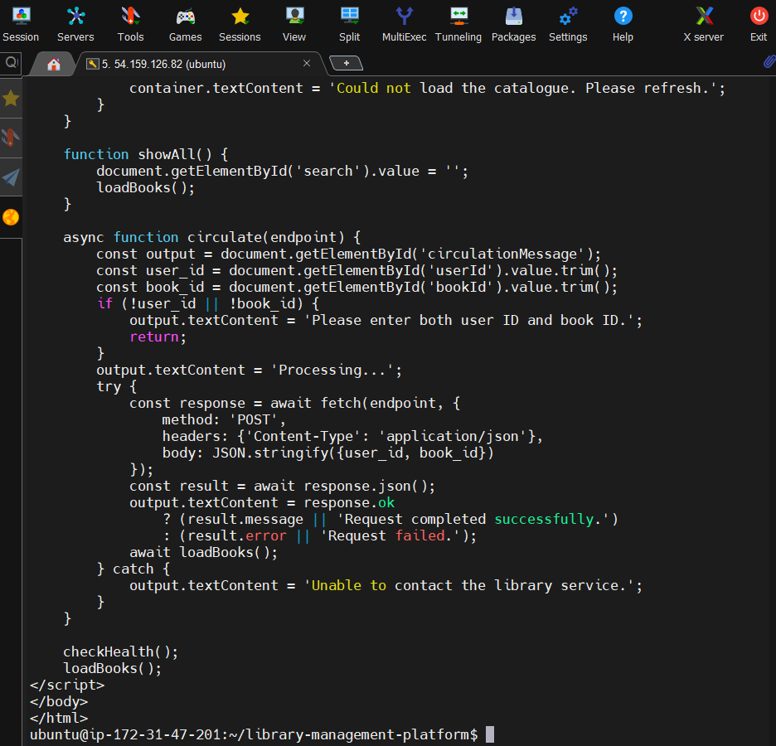
Start the container
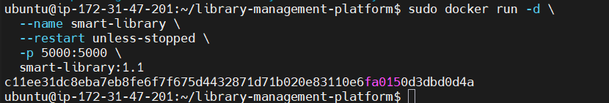

Check the container status
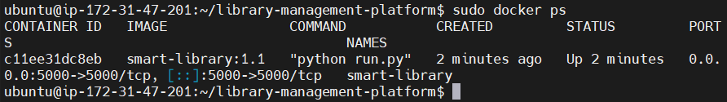
Test the homepage
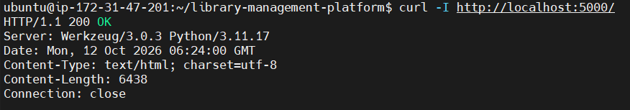
Open the platform in your browser
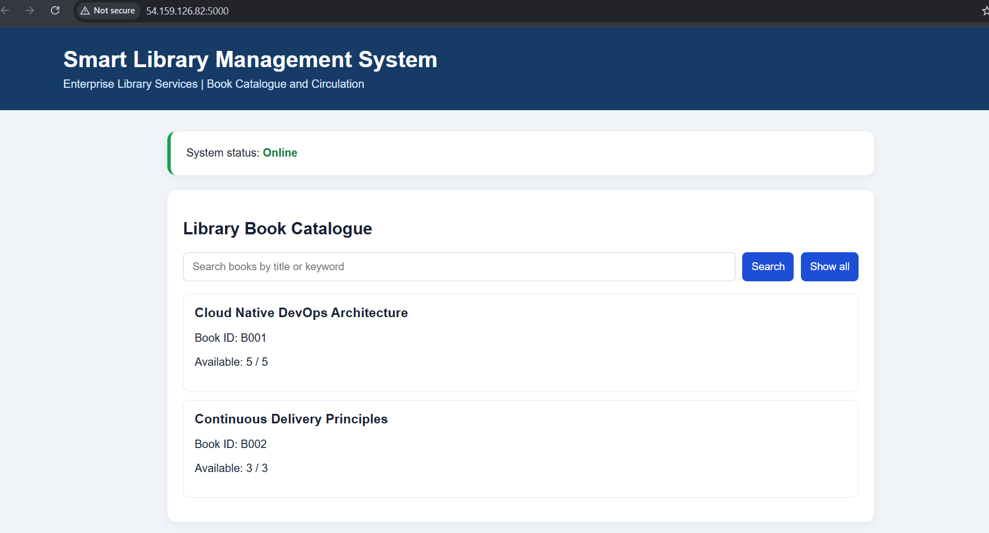
Step 1: Test the website
- Test 1: Show all books
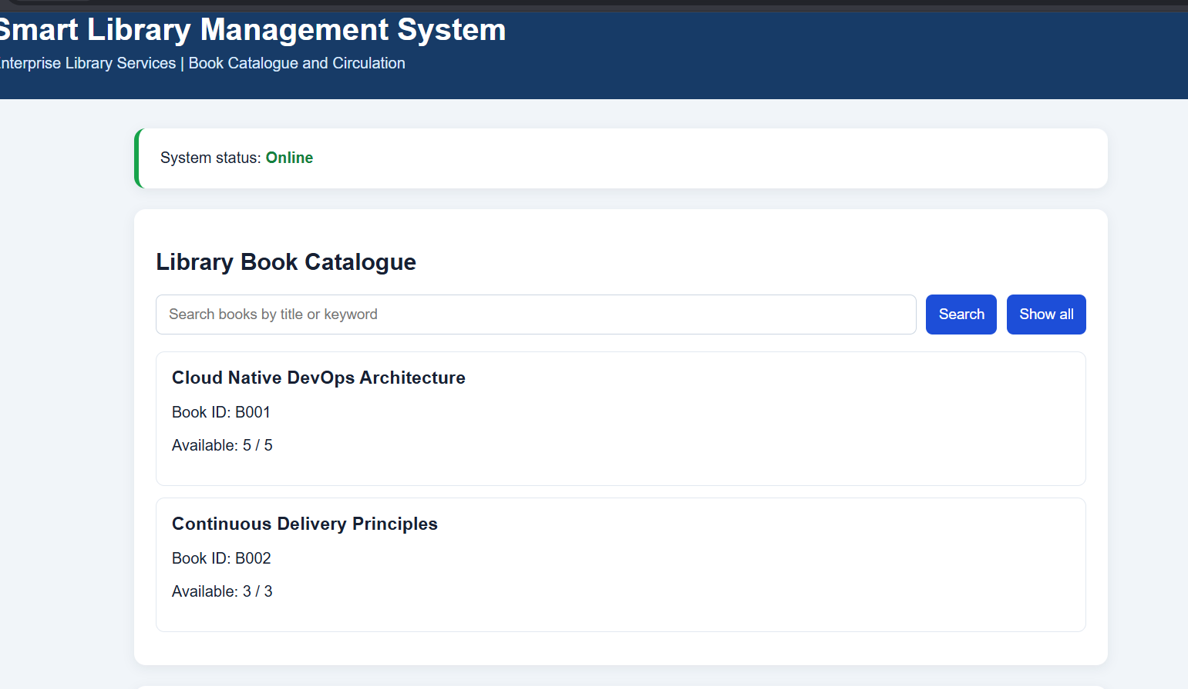

Test 2: Search functionality
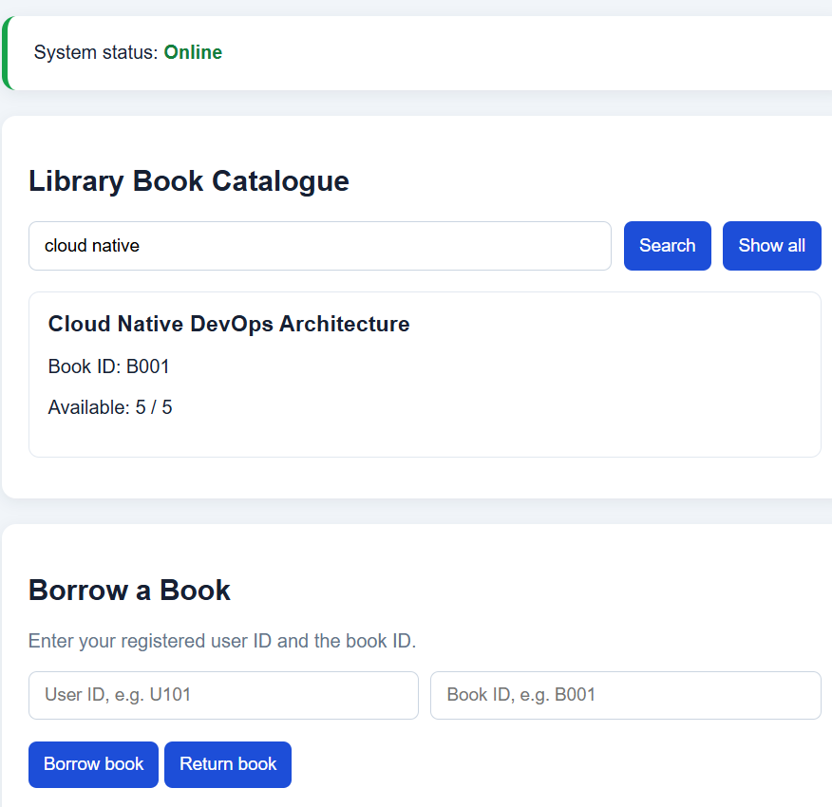

Back up your project
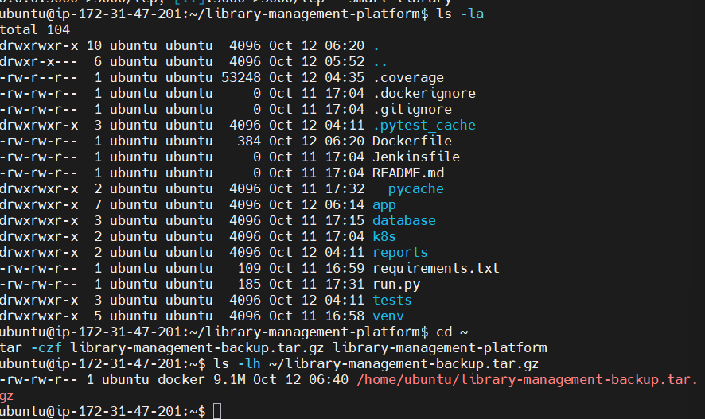

Step : Inspect your application files
1.Return to your project directory
2. List the files inside the application folder
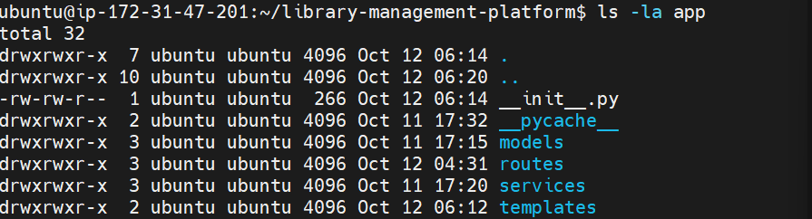

3. Check the main application code
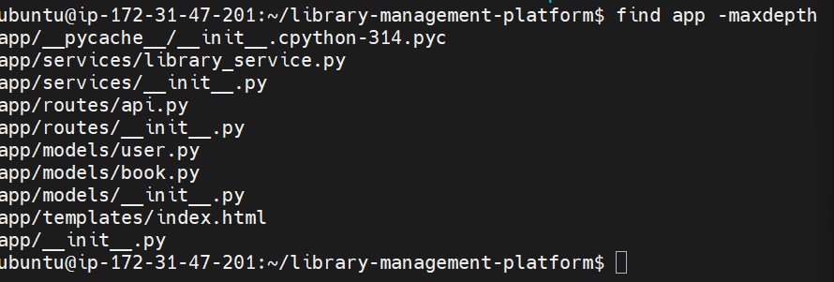

Step 1: Update the book catalogue
New books catalogue
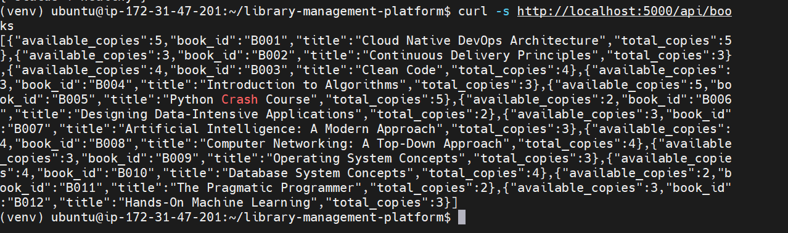
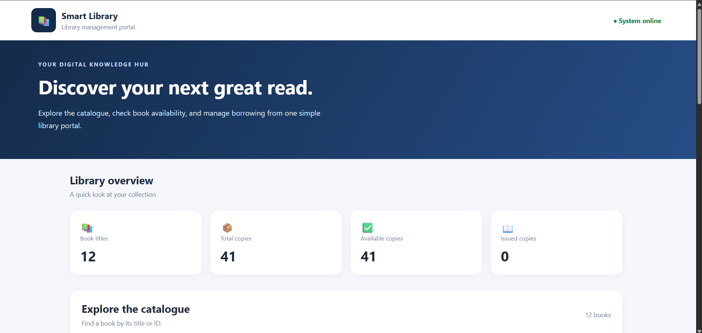

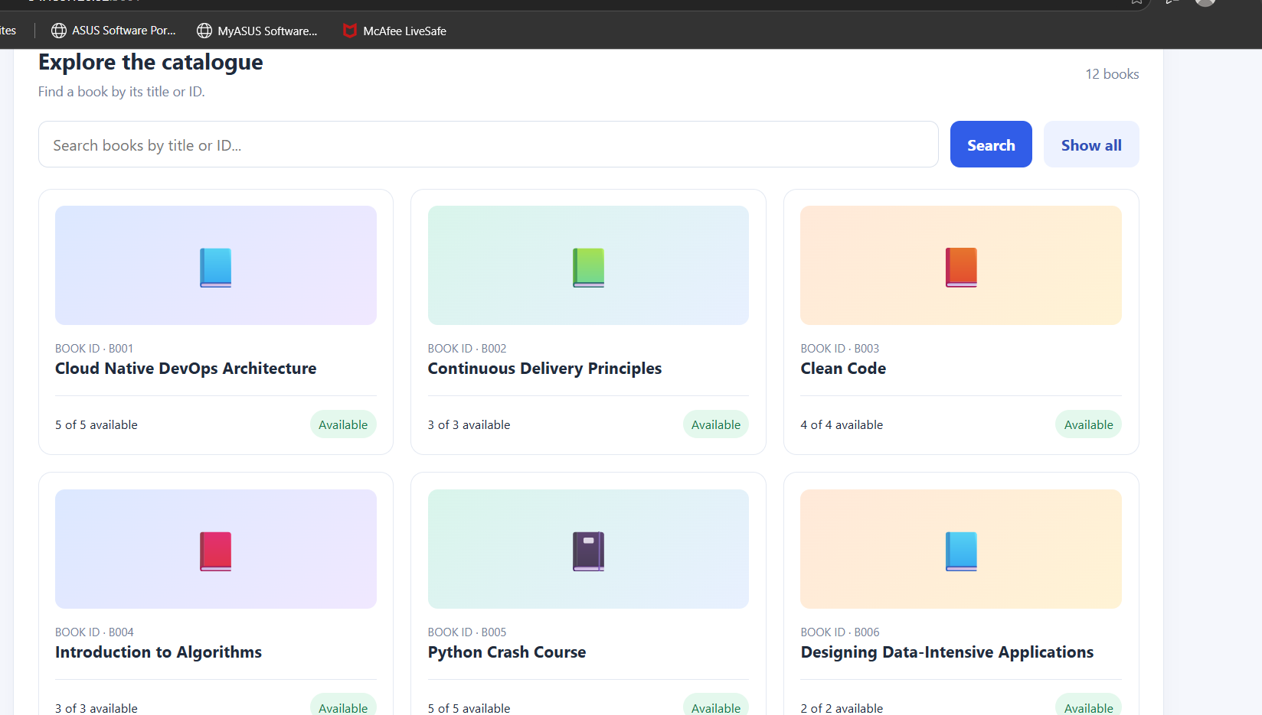

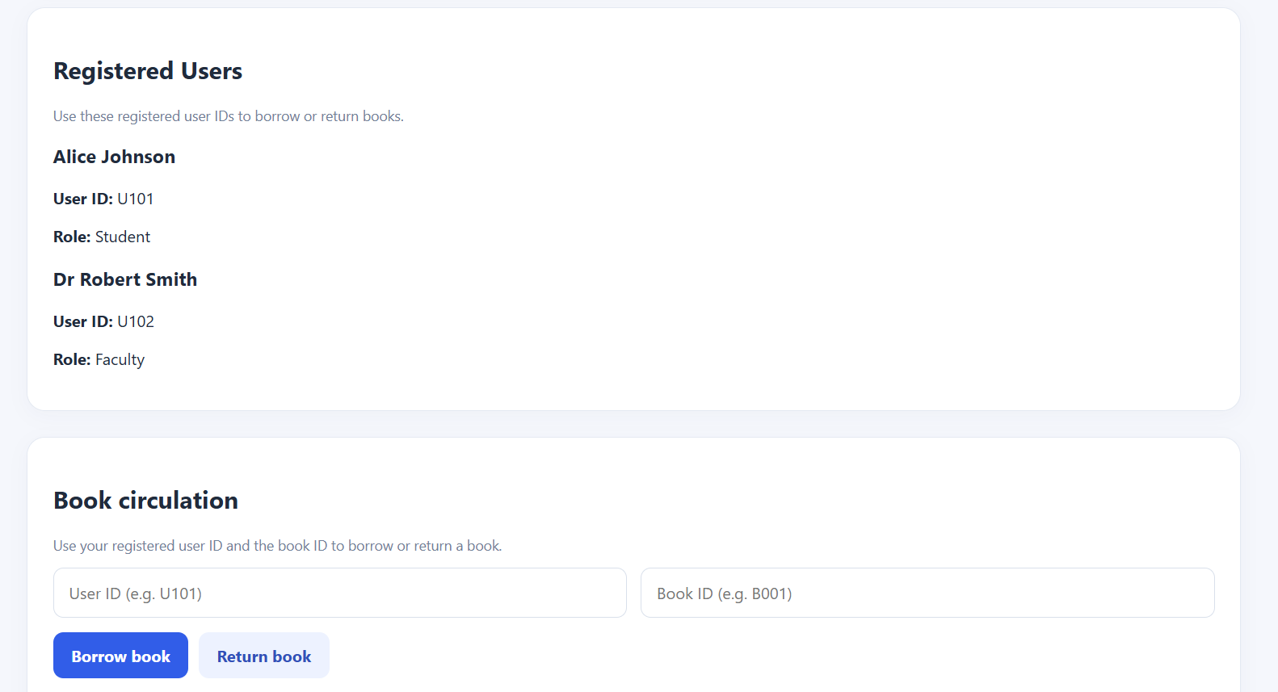

Book Borrowed
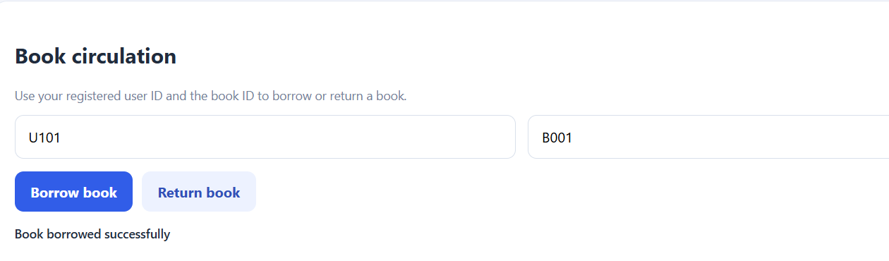

Available book count changes
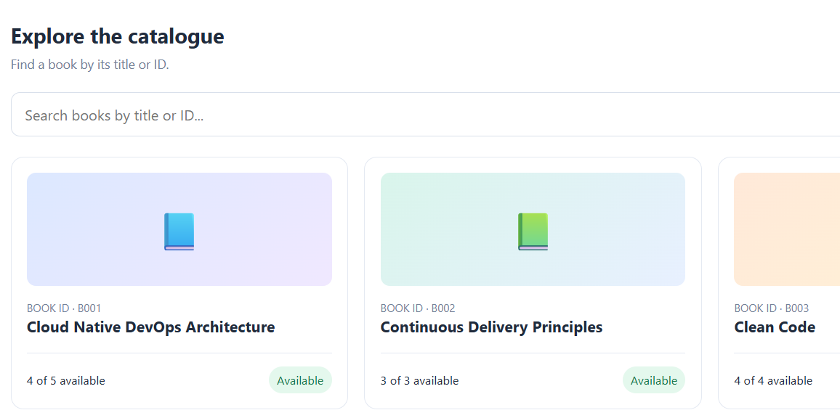

Verify public access
Step 1 — Check the running Docker container
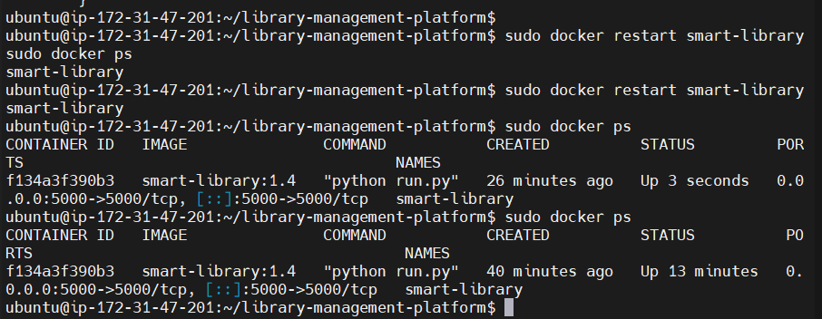
Step 2 — Find the EC2 public IP address
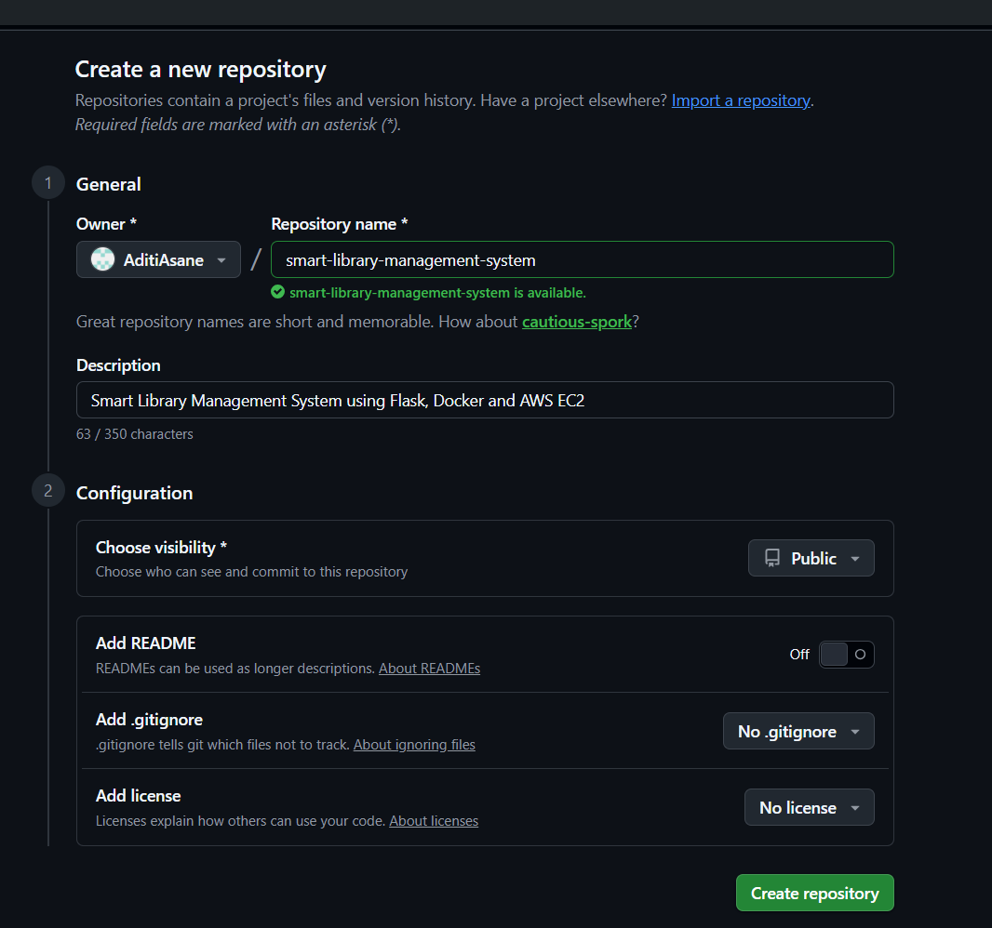

Initialize Git
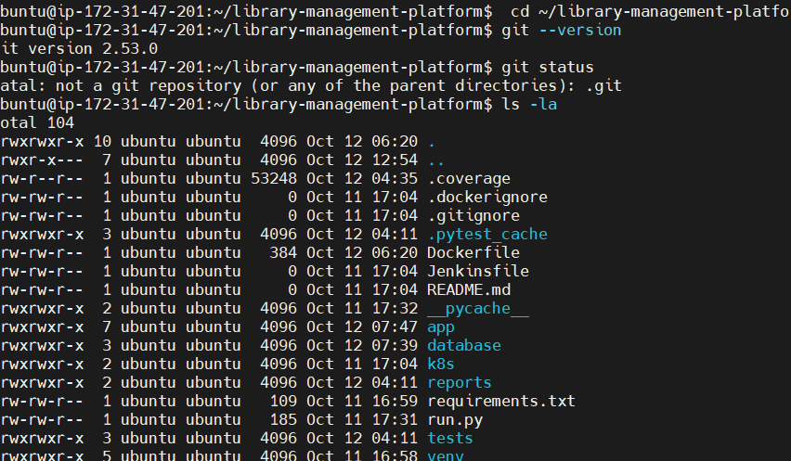

gitignore
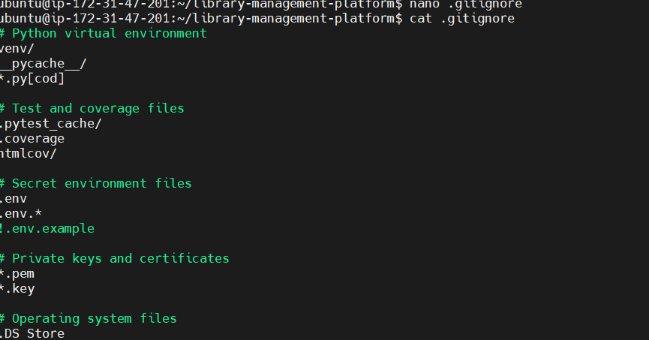
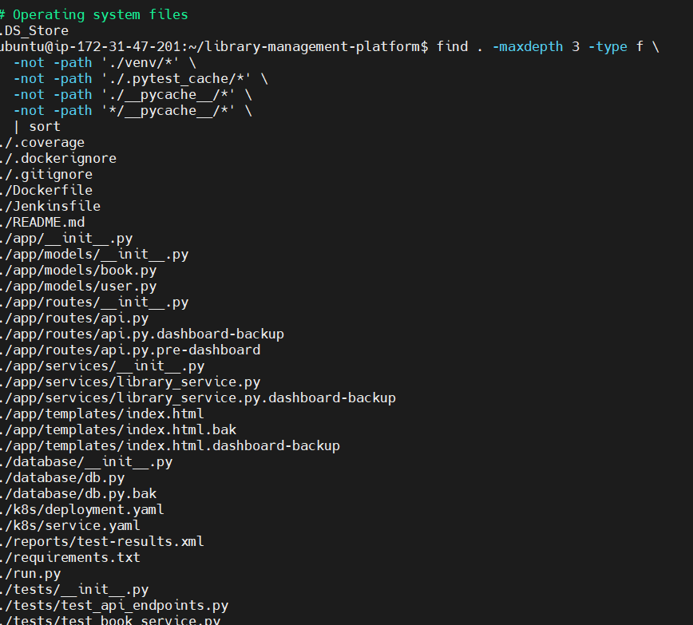
Git init
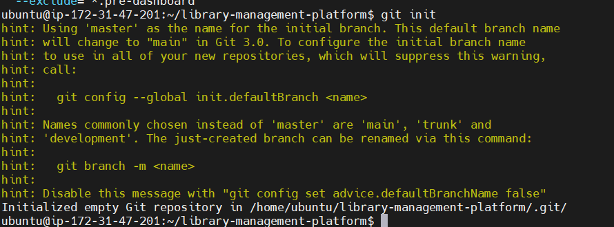
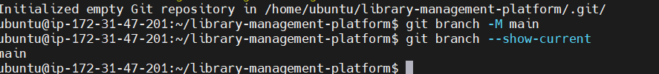
Git README.md
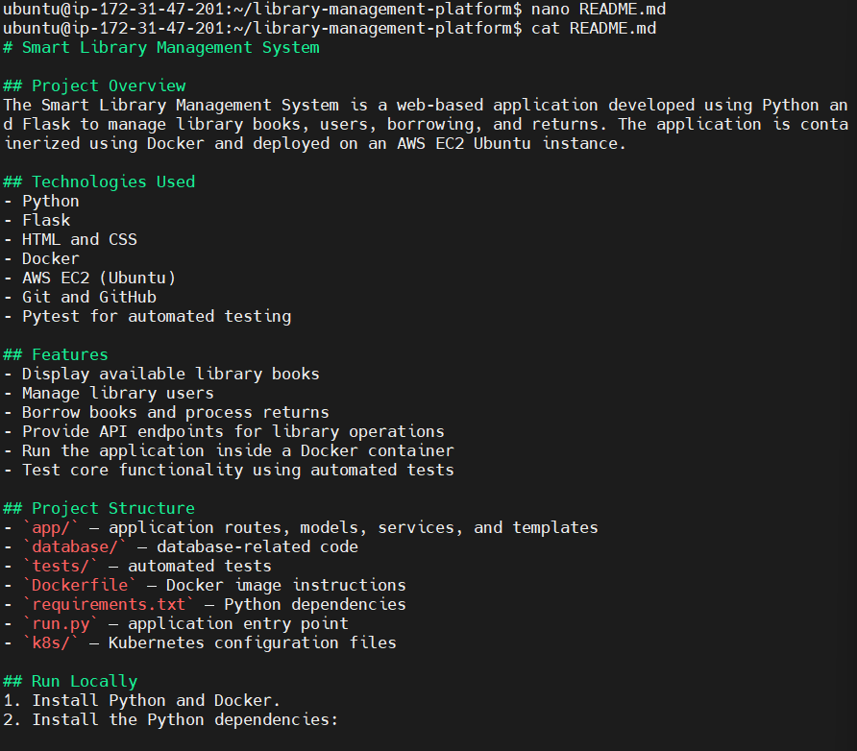

Stage your project files and check git status
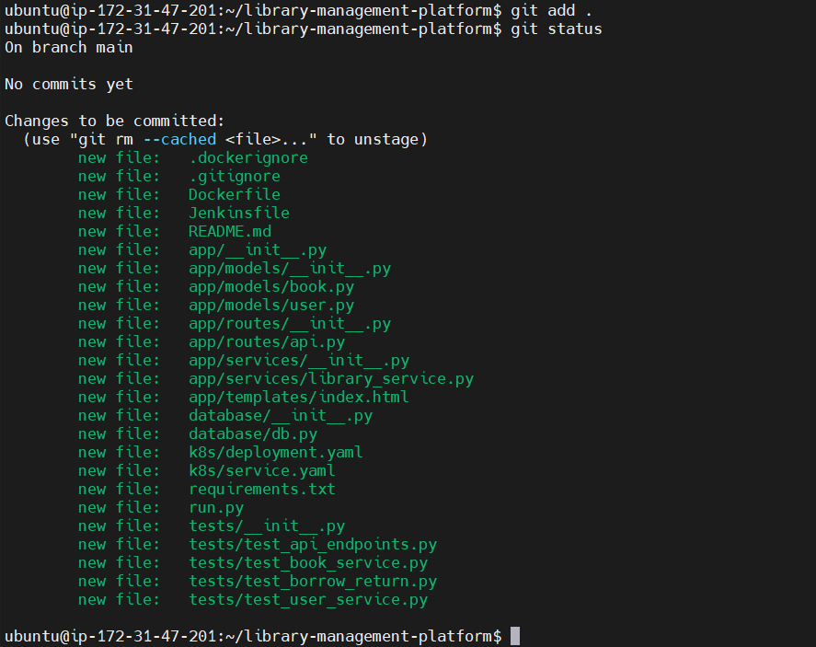

Create your first Git commit
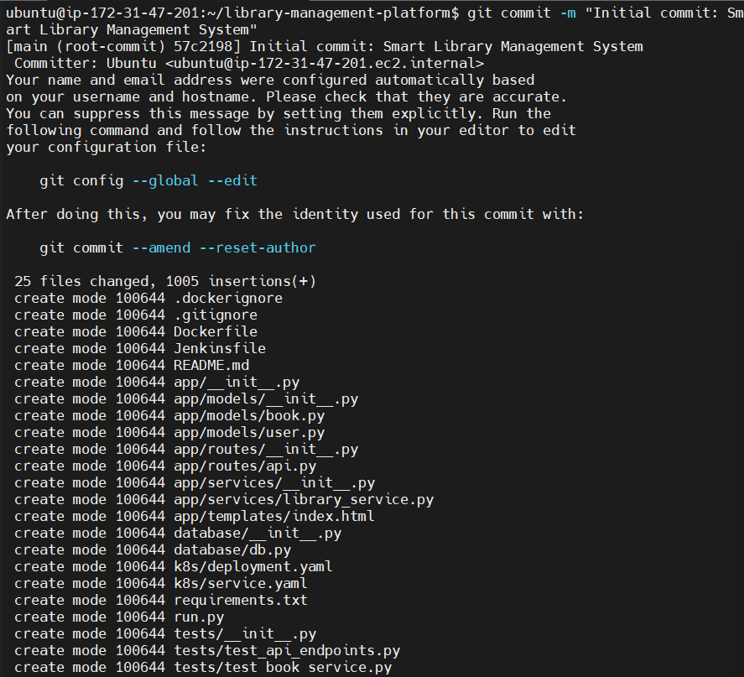
Configure your Git identity
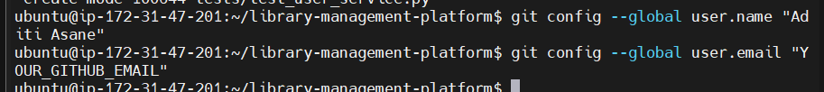
Connect to GitHub
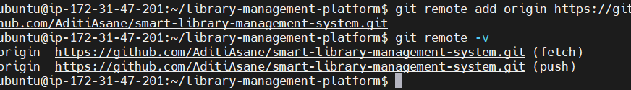
Upload project to GitHub
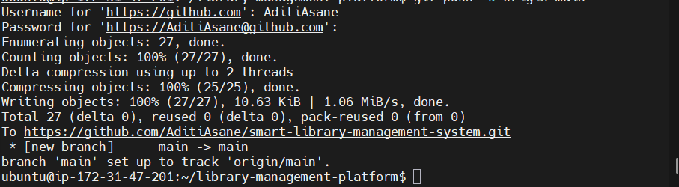
Connect git to Jenkins for CI/CD
Install Java
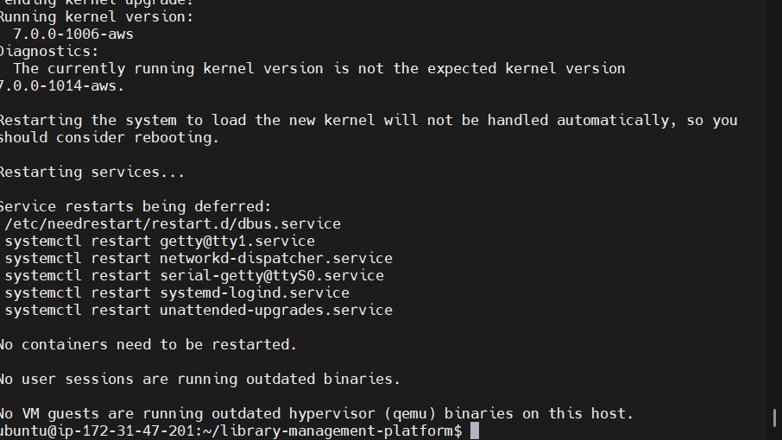

Download the Jenkins signing key
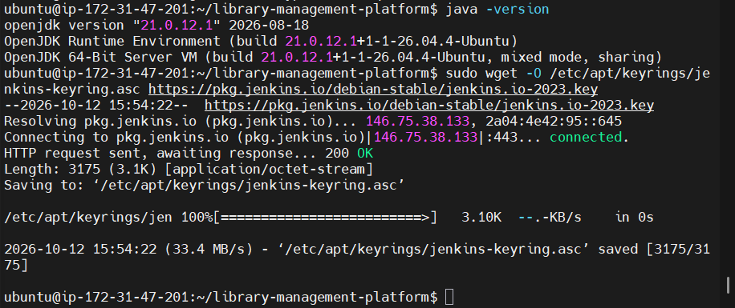
Add the Jenkins repository
Sudo apt update
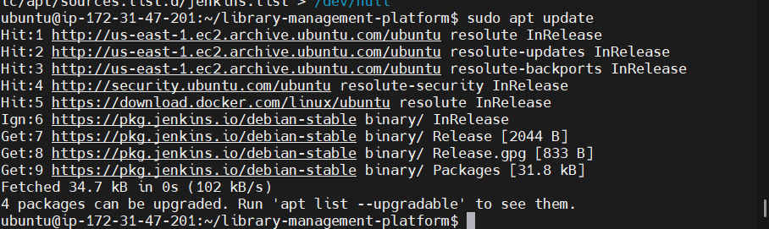
Install Jenkins
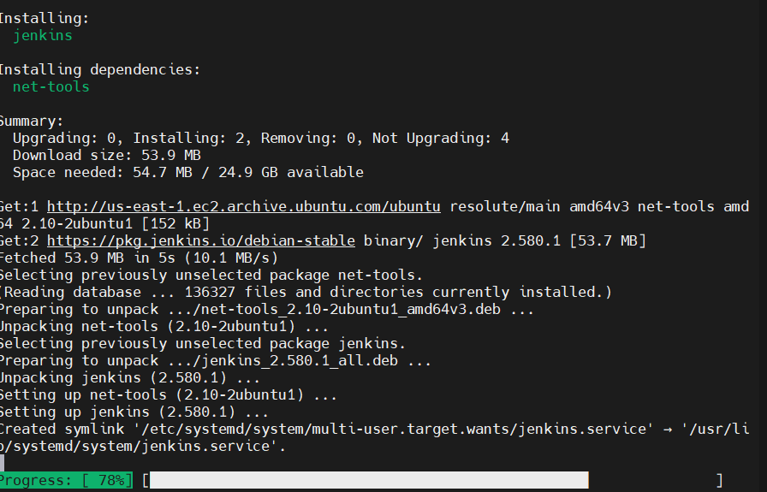
Start Jenkins
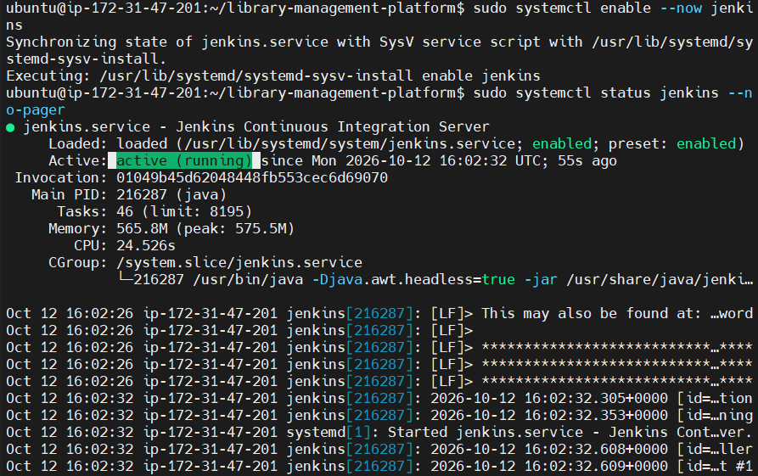
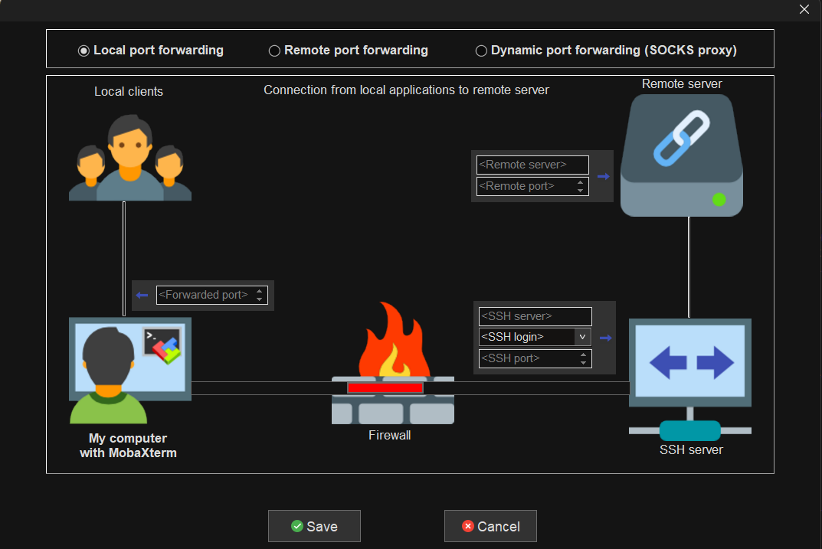

jenkins

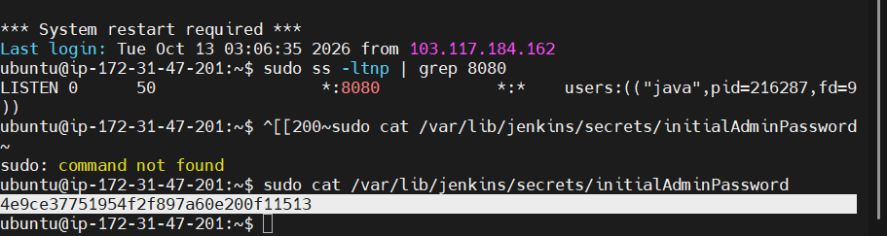

Check Jenkins permissions and the test setup
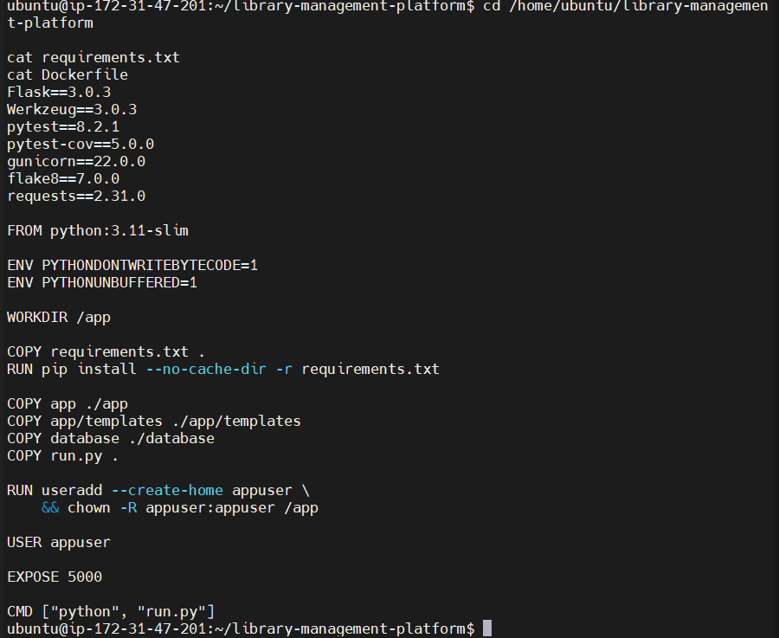

Check how the app stores its data before deployment
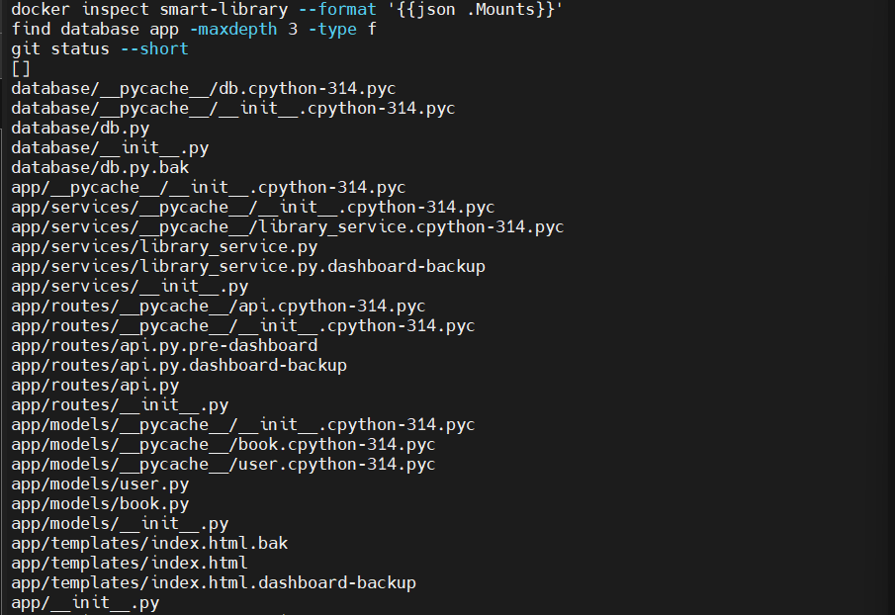

Run the tests
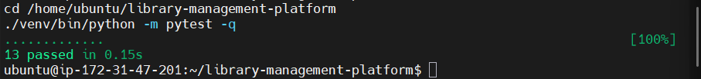

Check the Jenkins service
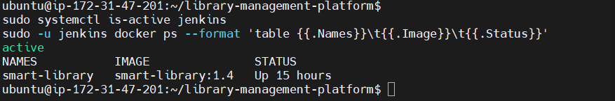

Step 1 — Create the Jenkinsfile
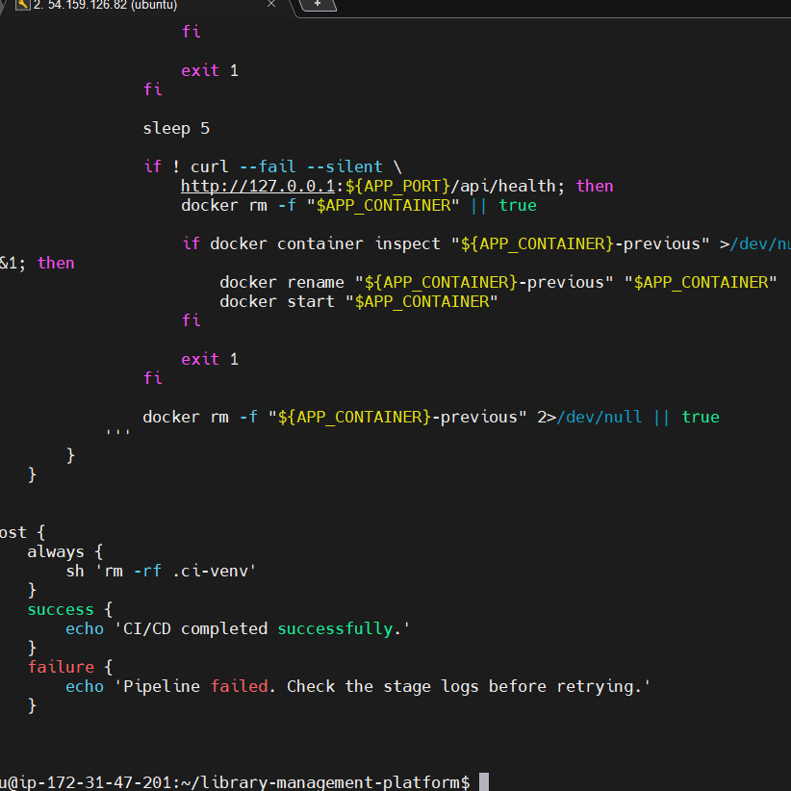
Commit the Jenkinsfile
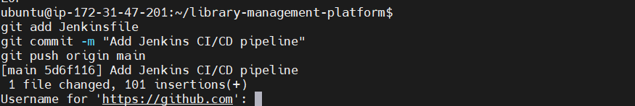

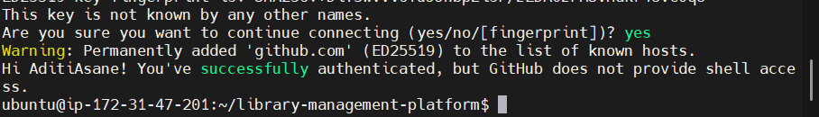

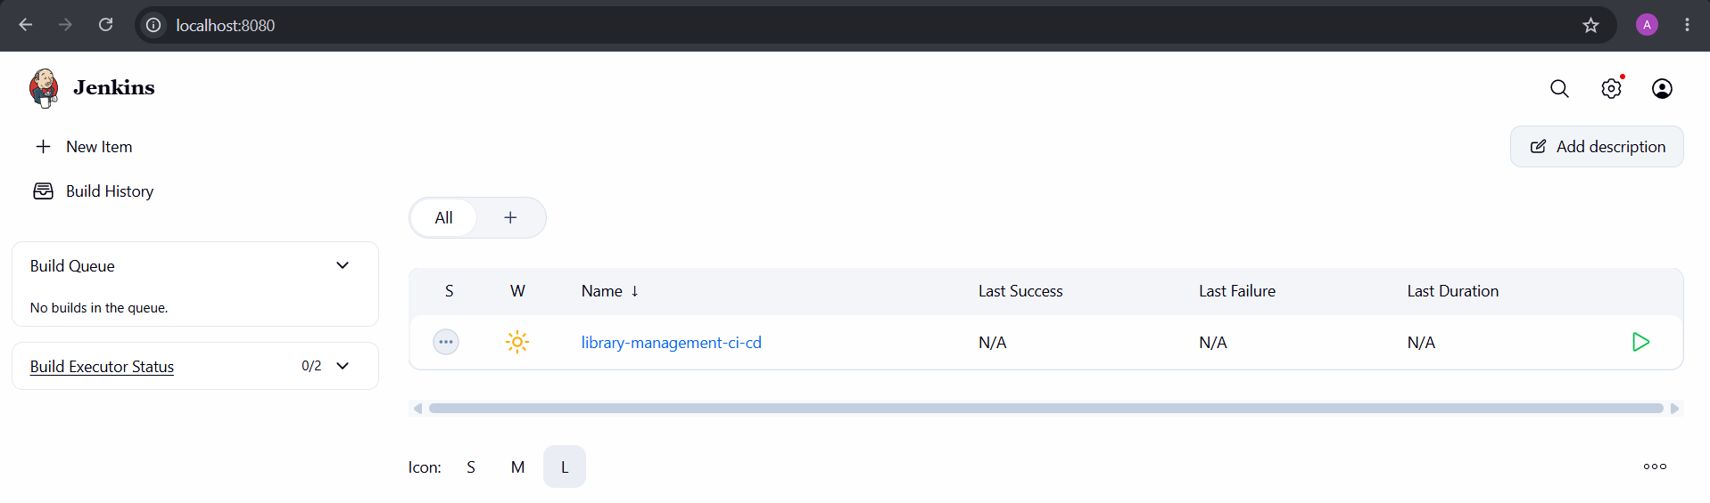

Deploy key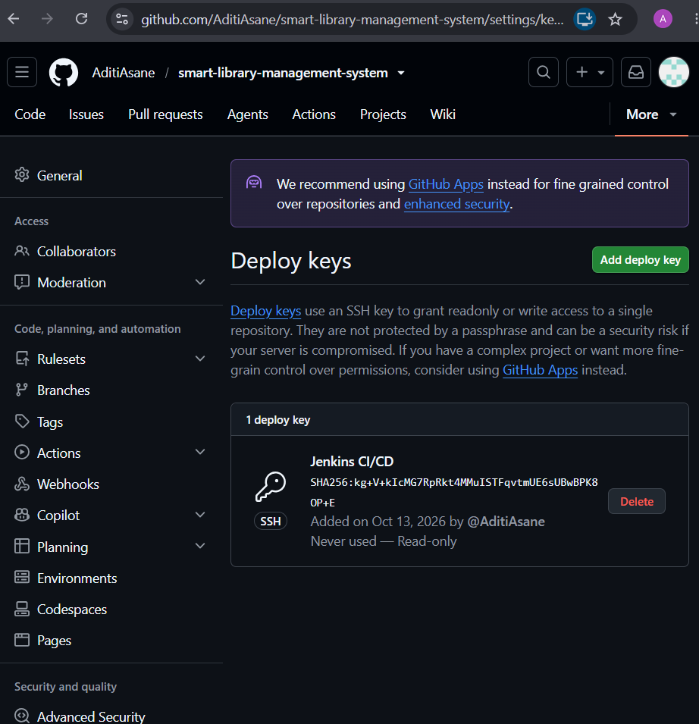

Jenkins Console Output
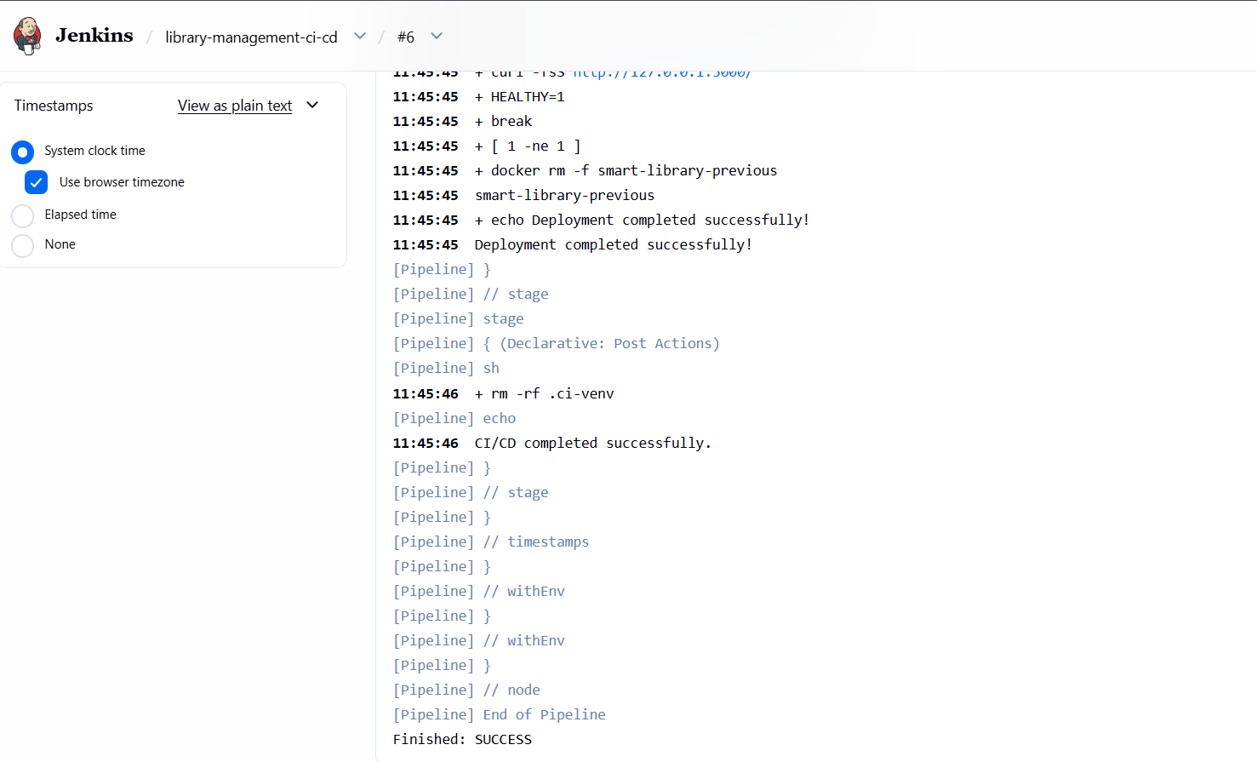
Stages
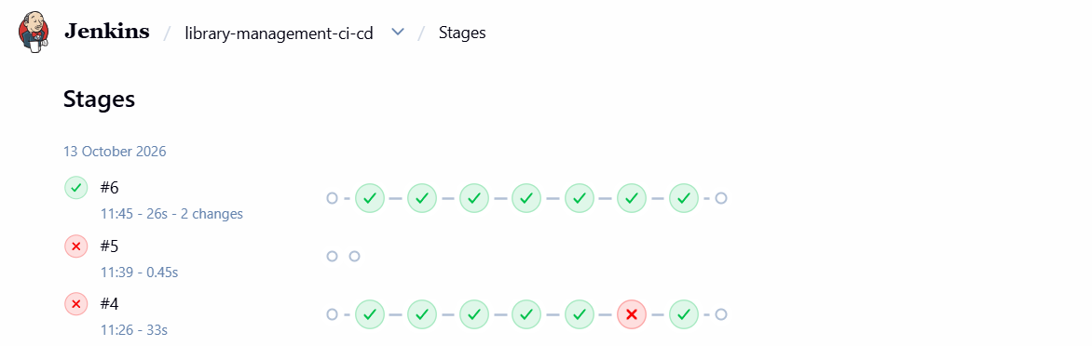
Stage view
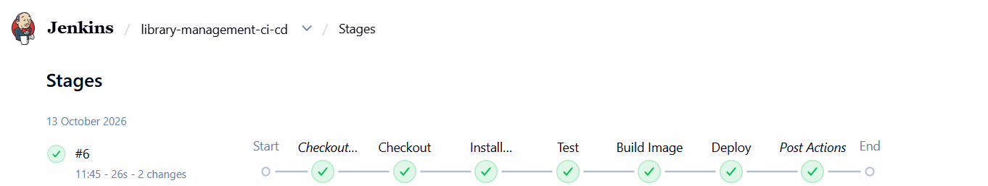

Deployment using Kubernet
Step 1: Install kubectl
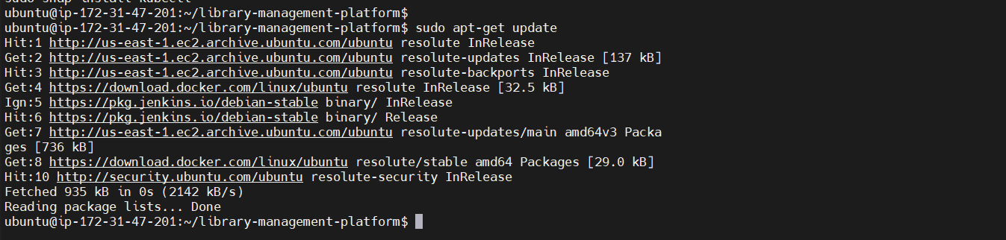
Install prerequisites for kubectl
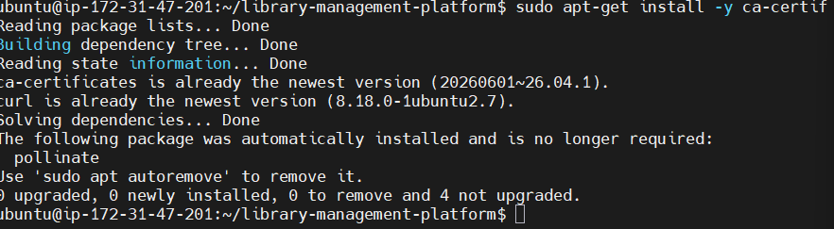
Refresh package information
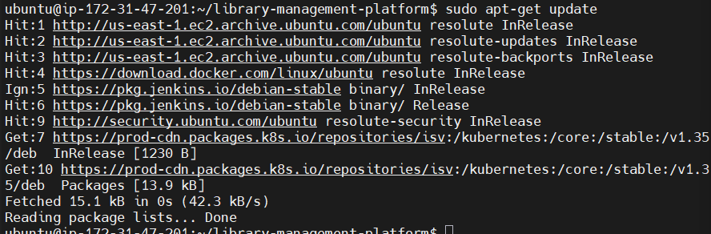

Verify that kubectl is installed
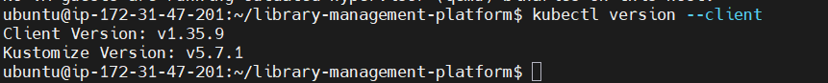
Install Minikube
Verify Minikube
Start Minikube
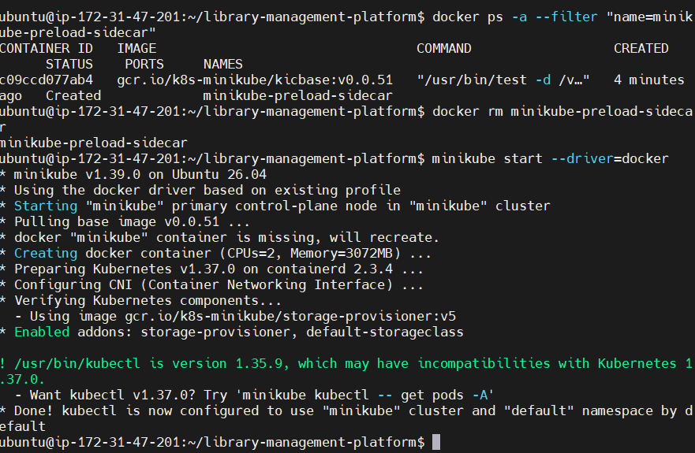

Create the Deployment YAML file
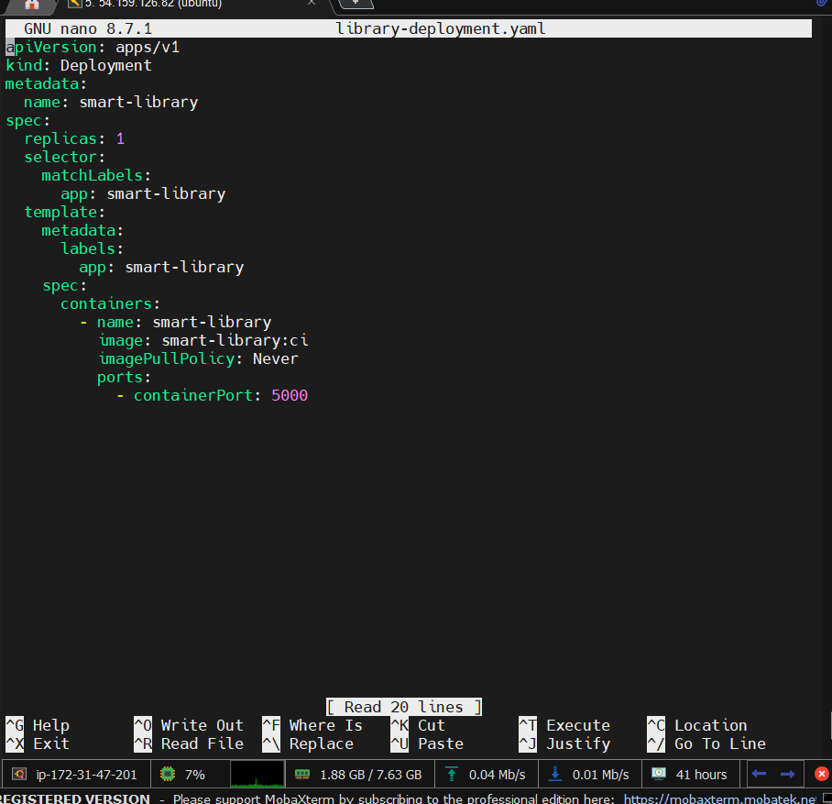
Deploy Smart Library to Kubernetes
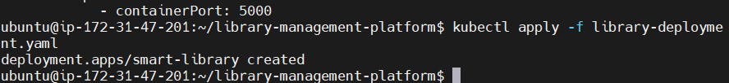

Create a Kubernetes Service
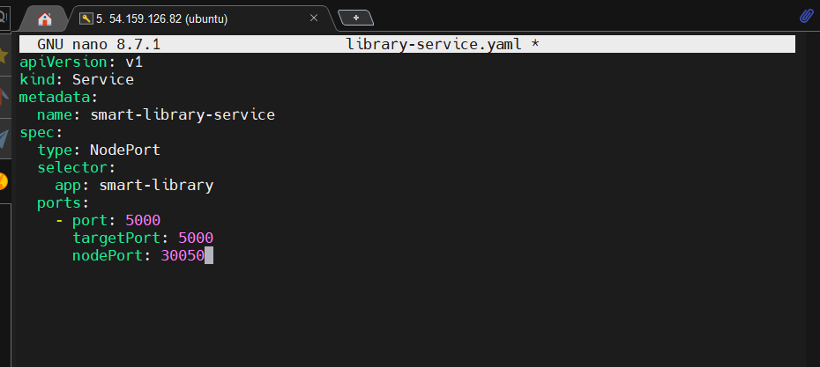

Deployment stage
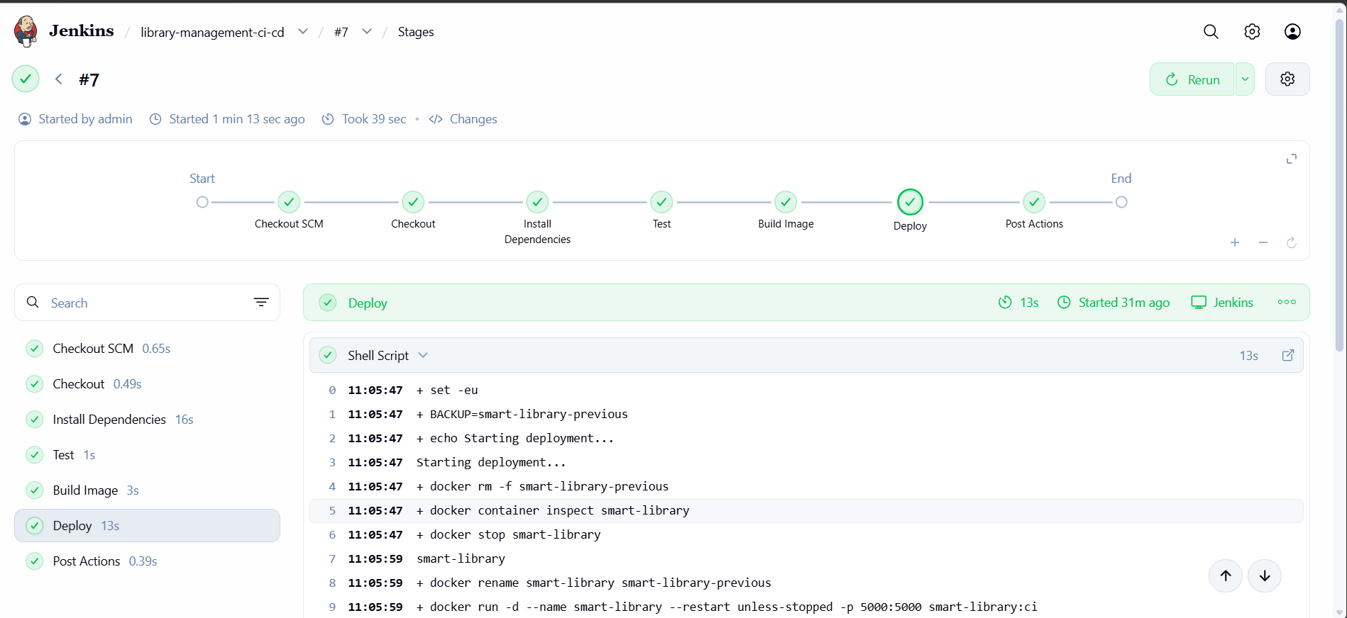
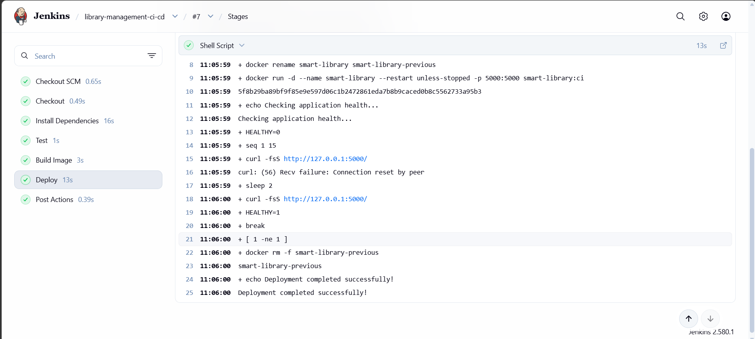

Instance stopped
